# Demo for Test Driven Development in Android Studio

This short demo is meant to show the use of Test Driven Development(TDD) with JUnit4 in Android Studio. A test class is a regular Java class which extends “TestCase”. For this demo we will use a simple calculator project which can add, subtract, divide and multiply and saves the result in a private field result.

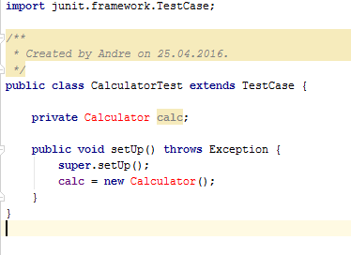

The Method *setUp()* will be used to initialize the class we want to test. The core idea of TDD is that the tests will be written before the real class. Since we don’t have a Calculator class yet we could create it now or use hotfixes to let Android Studio generate the class. When writing tests, you can use JUnit annotations like “@Test” to declare a function as a test. To check whether the test was successful you use assert functions to compare the *Result* field in our calculator class with the expected value.

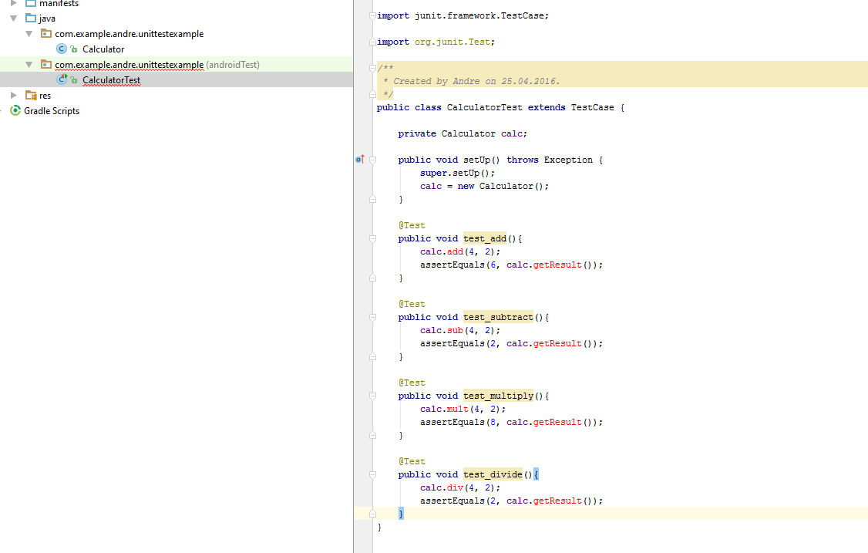

After writing some tests you can run them but since this is TDD and nothing has been implemented you will only get errors.

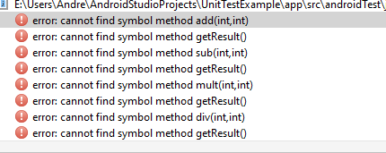

Now we know which methods still need to be implemented. We switch to our Calculator class and write the methods or generate them again via hotfixes. Now we can run our tests by right clicking on our test class and selecting *Run.*

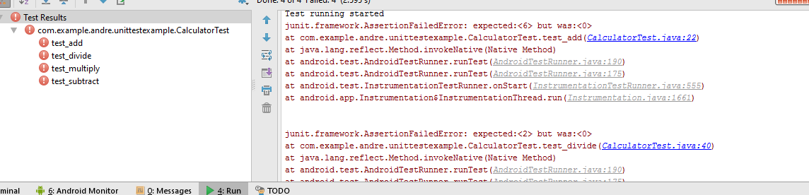

Since no logic has been written for our Calculator class all tests fail and we can now go and start implementing the methods which throw errors.

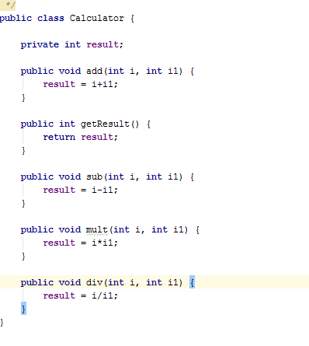

After implementing all methods and running our test class again we will see that they now all end positively.

